TOWNSVIEW SCHOOL
2019-2020 SCHOOL SUPPLY LIST: KINDERGARTEN

- 1 package of 24 Crayola pre-sharpened pencil crayons
- 1 package of 24 Crayola crayons
- 2 packages of 8 Crayola markers
- 2 packages of 12 HB pencils
- 3 white erasers with white plastic covers ( i.e Basic brand or Staedtler brand)
- 2 Elmers Glue Sticks, 40g
- 2 Poly duo-tang report covers (plastic) - blue
- 2 Poly duo-tang report covers (plastic) -orange
- 2 Poly duo-tang report covers (plastic) -red
- 2 Hilroy yellow exercise books – ½ plain & ½ ruled, looks like this:
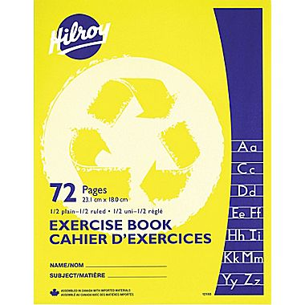
- 2 Expo Dry erase markers, blue
- 1 Fine-tip black Sharpie marker
- 2 boxes of Kleenex
- 1 box of Large Ziploc bags
- 1 package Lysol wipes (80 count)
______________________________________________________________________________

NOTES:

- Townsview School is a scent-free and peanut-free environment.
- Please note that students will need a lunch box, book bag and sneakers with non-marking soles for Phys. Ed and the classroom.
- Parents have the option to buy a school pack for $45 or purchase the supplies on their own from the list above.
- If you wish to buy a school pack, we will begin accepting payments on “Welcome to K Day”, May 30th. Payments can be made with cash or cheque at the office or using School Cash Online. https://district.schoolcashonline.com/. Please print your transaction receipt for your records. This option will be available online until Monday, June 24th.
- The first day of classes for students will be either Tuesday, Sept 3 or Wednesday, Sept 4, 2019, staggered entry. You will receive notification of which start date by mail.

